**Interpolation Methods**

Updated 7/9/25 – ELW

Examples of interpolation methods for habitat suitability model point location data. All examples are shown using the station data (black points) and area (dark gray area) specified in the following figure. Options currently include nearest neighbor, thin plate spline, inverse distance weighted, and ordinary kriging. Additionally, an ensemble approach can be used to combine any of the listed methods.

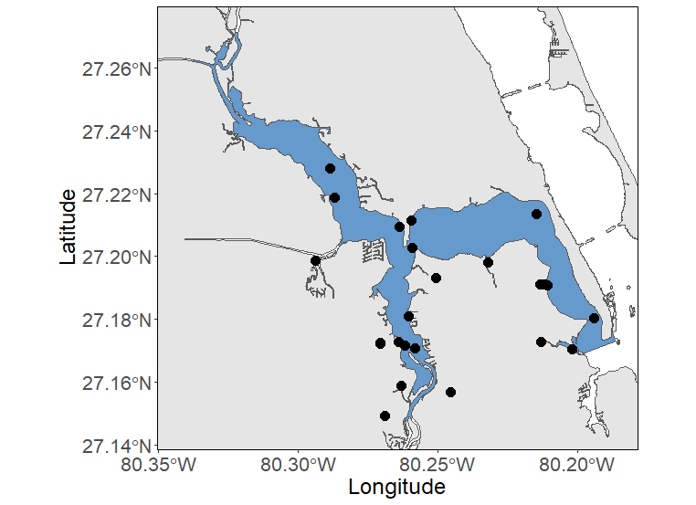

**Nearest neighbor**

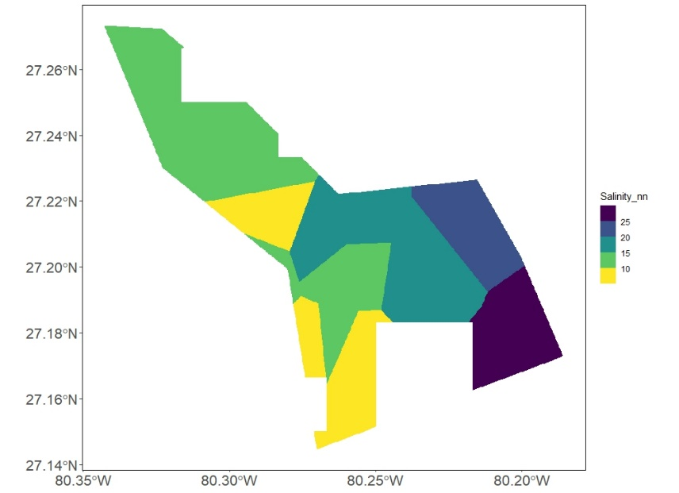

NN 1. Values from nearest neighbor interpolation.

Unknown values are estimated by assigning the value of the nearest known point. This is the simplest method to apply and requires less processing power. It may be useful for large areas with minimal complexity. The area of interest is divided into sections based on proximity to known station point locations. The value of the known point is applied to the entire section.

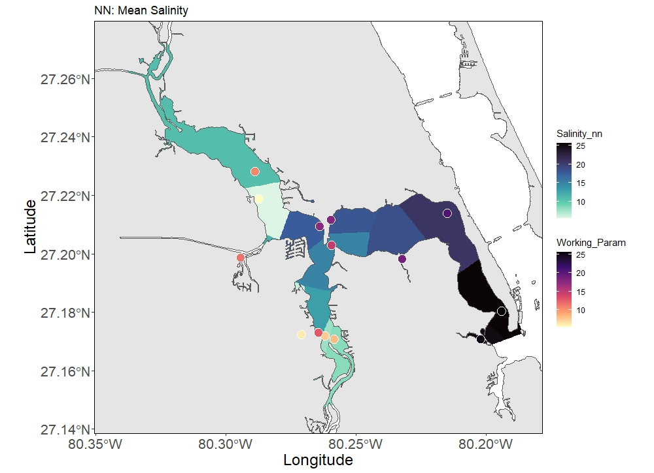

NN 2. Predicted values from nearest neighbor interpolation applied to PicoGrid with salinity point values shown.

**Thin plate spline**

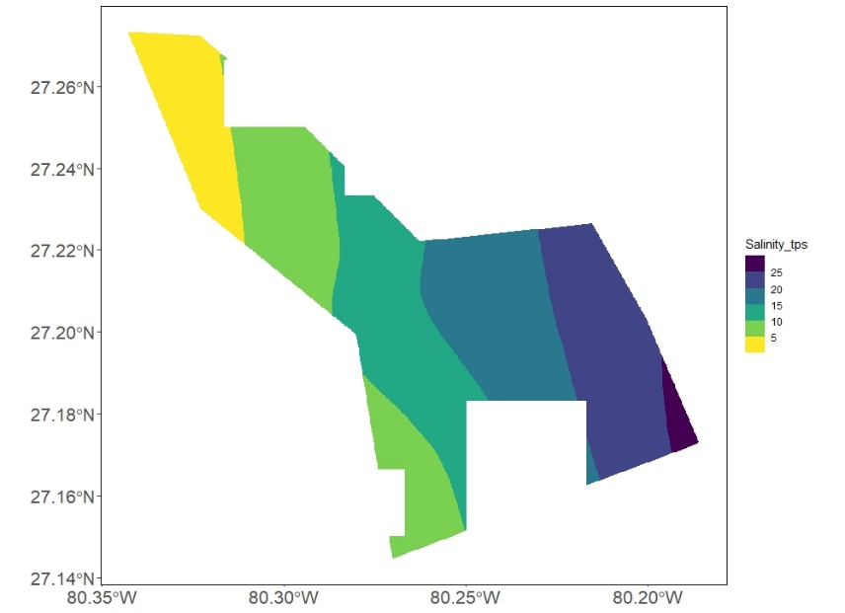

TPS 1. Values from thin plate spline interpolation.

Unknown values are estimated by fitting a smooth continuous surface through scattered points using piecewise polynomial functions. Bending (i.e., variability) in the surface is minimized to create a smooth transition among known points.

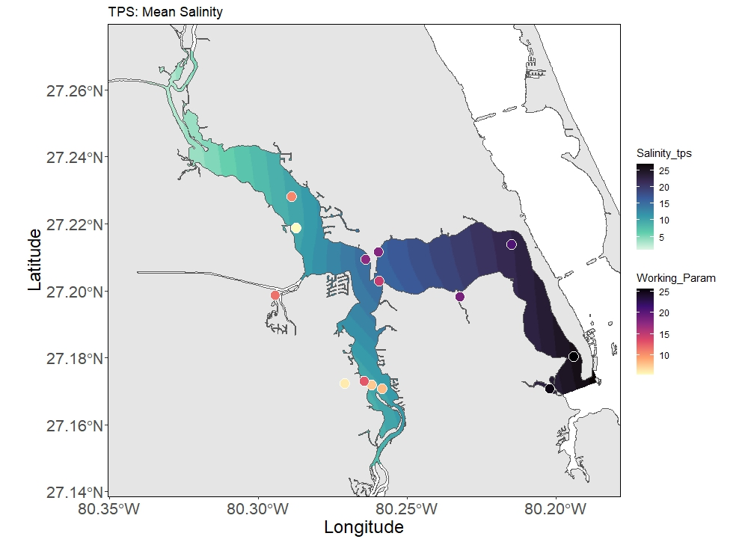

TPS 2. Predicted values from thin plate spline interpolation applied to PicoGrid with salinity point values shown.

**Inverse distance weighted**

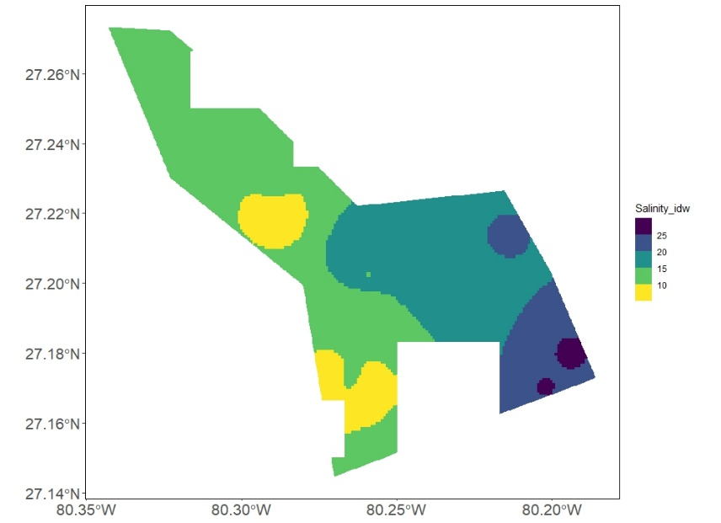

IDW 1. Values from inverse distance weighted interpolation.

Unknown values are estimated based on the values at all nearby known points. This method assumes that closer values are more similar and have a greater influence on the predicted value weighting the influence of known points inversely to their distance from the unknown point. Once values are predicted, all similar values that touch are connected into polygons of set value and assigned back to the PicoGrid cells based on grid ID.

**Ensemble**

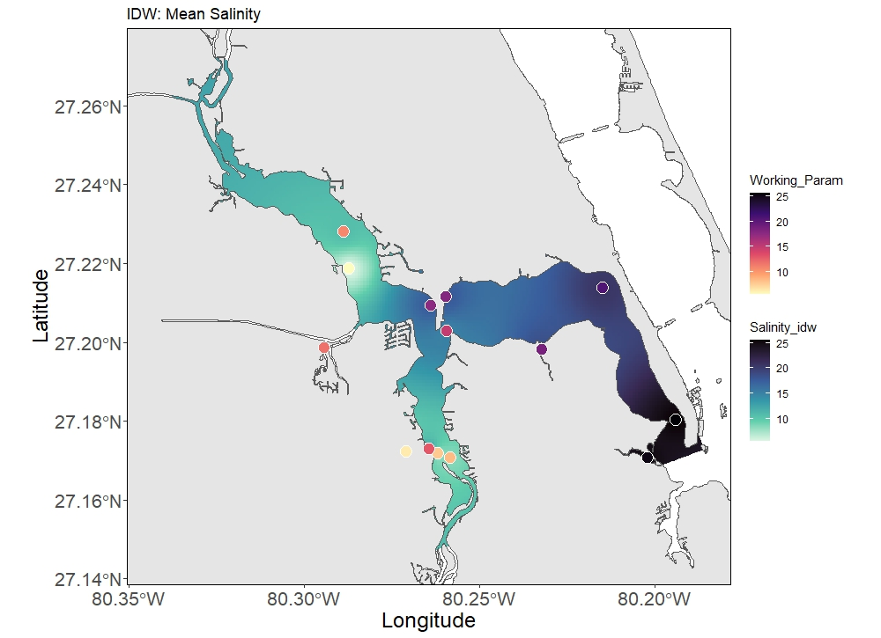

IDW 2. Predicted values from inverse distance weighted interpolation applied to PicoGrid with salinity point values shown.

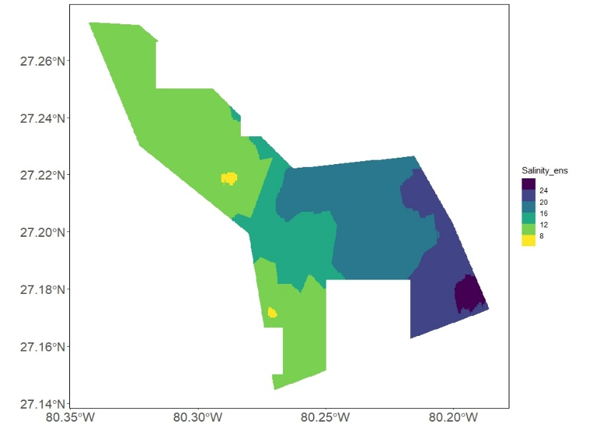

ENS 1. Values from ensemble model determined from each model’s interpolation and weight.

Unknown values are estimated based on the model types specified by the user. Model weight is then applied equally or based on user-provided values (0-1) by multiplying the model output value by the weighted value. All weighted model values are added to achieve the final ensemble model value. Once ensemble values are calculated, all similar values that touch are connected into polygons of similar value and assigned back to the PicoGrid cells based on grid ID.

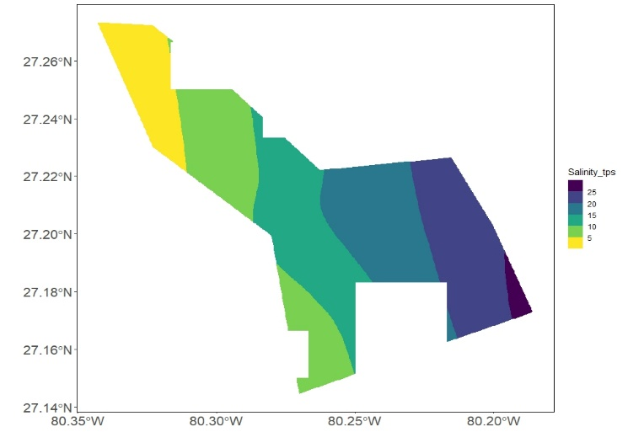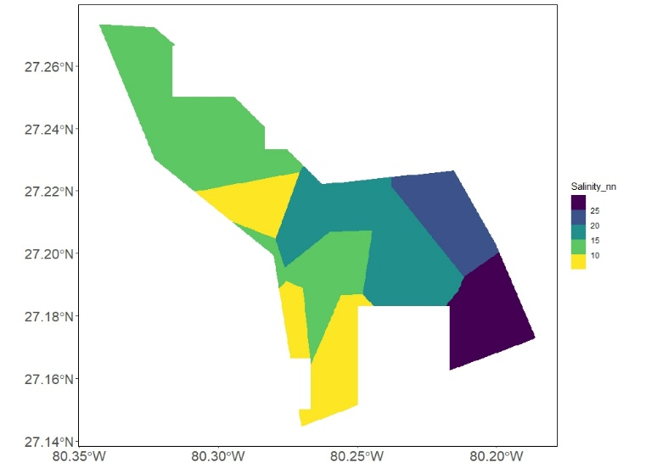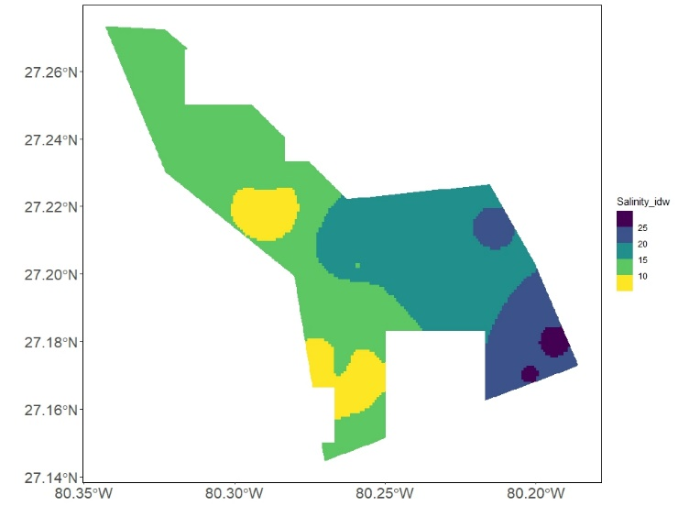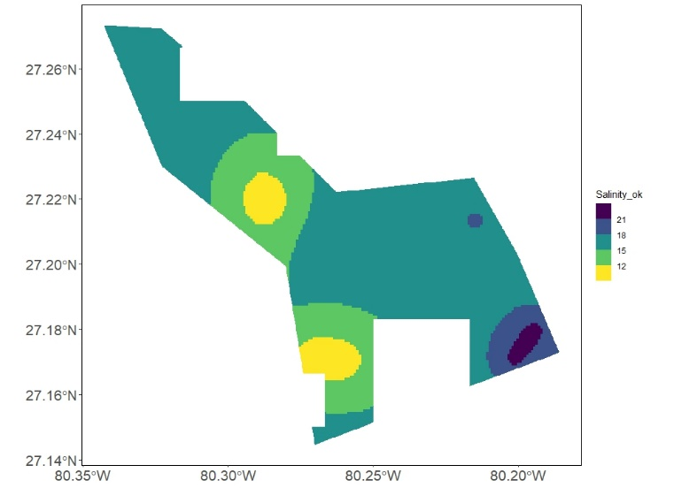

ENS 2. Interpolated values from nearest neighbor (top left), thin plate spline (top, right), inverse distance weighted (bottom, right), and ordinary kriging (bottom, right) models.

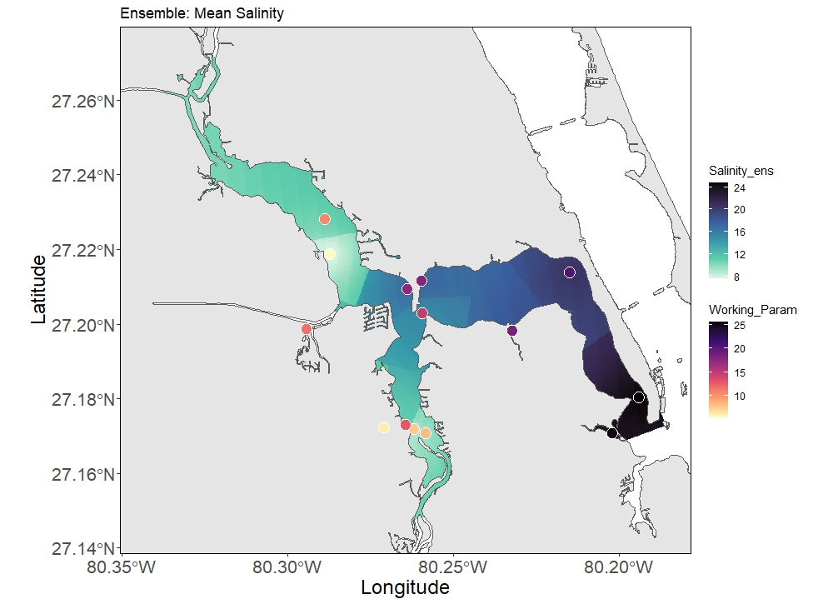

ENS 3. Predicted values from ensemble modeling applied to PicoGrid with salinity point values shown.